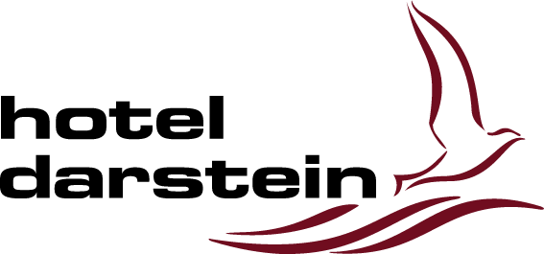
HOTEL DARSTEIN
Website Redesign Proposal
WordPress & Elementor Redesign Proposal for Hotel Darstein

1. Project Overview
Hotel Darstein already has a strong identity and excellent location presentation, however the current website design and structure feel outdated compared to modern hospitality websites.
The purpose of this redesign project is to modernize the visual experience, improve mobile usability, increase wedding and event inquiries, improve booking experience, and create a stronger premium impression for hotel guests and event customers.
The redesign will maintain the existing Hotel Darstein branding while significantly improving design quality, speed, structure, SEO performance, and overall user experience.

2. Why Redesign the Website?
- Improve First Impression: Visitors form an opinion within seconds. A modern and elegant website increases trust and booking interest.
- Improve Mobile Experience: Most hotel visitors now browse from mobile devices. The new website will be fully optimized for mobile and tablet users.
- Increase Event & Wedding Inquiries: Dedicated landing pages and improved calls-to-action will help increase inquiries for weddings, celebrations, and events.
- Improve Speed & SEO: The new setup will improve loading speed, Google ranking, security, and overall performance.
- Easy Future Management: The new website will be designed for easy management using Elementor. Hotel staff will not need to hire expensive agencies for simple updates or small changes. At the end of the project, training will be provided so the team can confidently manage and maintain the website independently.

3. Scope of Work
- Complete Elementor-based redesign
- Responsive mobile & tablet optimization
- Improved navigation & structure
- Modern hospitality-focused design
- Booking & event inquiry optimization
- SEO optimization
- Performance optimization
- Security improvements
- Hosting migration and setup
- DNS and SSL configuration

4. New Custom Pages
- Bus Reisen
- Persische Hochzeit Club
- Trauerfeier
- Geburtstag

5. Hosting & Technical Migration
The website will be migrated to a managed WordPress VPS hosting environment using InMotion Hosting (8GB RAM / 150GB SSD).
- Full website backup
- Safe migration process
- SSL setup
- DNS configuration
- WordPress optimization
- Testing before launch
- Downtime minimization

6. Recommended Premium Tools & Plugins
Tool / Plugin | Purpose | Estimated Annual Cost
Elementor Pro | Premium page builder | €60–100
WP Rocket | Speed optimization | €60
WPML | Multilingual support | €100–150
Security & Backup Plugins | Security and backups | €50–100
InMotion VPS Hosting | Managed WordPress VPS | €400–700/year

7. SEO & Performance Optimization
- Page title optimization
- Meta descriptions
- Image optimization
- Mobile SEO improvements
- URL structure improvements
- Basic schema optimization
- Performance and caching optimization

8. Optional Multilingual Package
The website can optionally support both German and English languages using WPML.
Although modern browsers can automatically translate websites, a professionally managed English version still improves international guest trust, tourism visibility, and wedding/event inquiries.

9. Project Investment
Service | Price
Full Website Redesign | $2,000
4 New Custom Pages | $1,000
Hosting Migration & Setup | $400
Domain & DNS Transfer | $120
SEO & Performance Optimization | Included
Optional WPML Multilingual Package | $800
Base Project Total: $3,520

10. Estimated Timeline
- Planning & structure: 3–5 days
- Design phase: 1–2 weeks
- Development: 2–3 weeks
- Migration & testing: 3–5 days
- Final launch: 1 day

11. Similar Hotel Website Inspirations
- https://www.seehotel-niedernberg.de/
- https://www.hotel-hoeri.de/
- https://www.schloss-hotel-kronberg.com/
- https://www.vila-vita-marburg.de/
- https://www.ameroncollection.com/

12. Final Notes
This redesign project is intended to position Hotel Darstein with a modern premium hospitality presence that improves guest confidence, event inquiries, and long-term usability.
We look forward to delivering a high-quality website experience aligned with the hotel's reputation and future growth.

